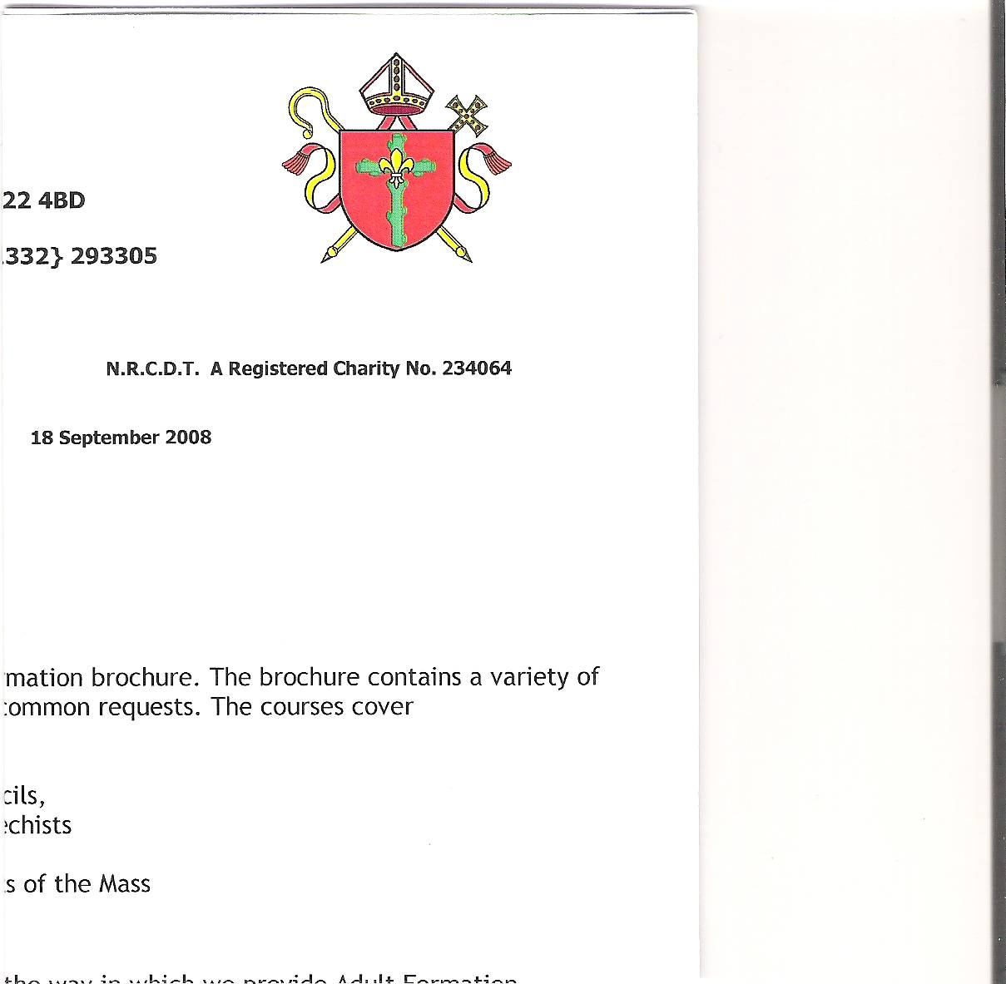

**Holy Cross Parish**

**Hucknall**

**EXTRAORDINARY JOINT PARISH PASTORAL COUNCIL & FINANCE MEETING**

**5th FEBRUARY 2025**

**ATTENDEES:** **APOLOGIES:**

Simon Clunie - Chair Father Richard

Lauren Whitehouse - Minutes Olympia Blaj

Vivien Flynn Chris Wisniewski

Bill Flynn Bodwell Mendy

Sue Hanson

Lucas Ortega

Vaughan Gallagher

**WELCOME AND APOLOGIES**

Following the opening prayer by Simon, he welcomed everyone to the meeting and noted apologies received.

Simon thanked Vaughan for all his hard work on the heating report. He then turned the meeting over to Vaughan to report back on the progress regarding the heating & the fire exit.

**HEATING**

**Tenders**

There was an around the table discussion about the received tenders. The preferred tender was H&V in Bulwell who installed the original heating system in the church in 1986 and have more recently worked with the Arnold Parish. The cost was quoted at £40,506 + VAT.

We can’t repair the current system in the church as there are no longer parts available for the system. It was noted that the costs in the economic climate are only going up.

Father Richard sent word that he wanted the work to go ahead. It was unanimously agreed that the council wanted to go forward with the work.

This will be need to be ratified by the Diocesan Office before work can begin.

**Action**: Vaughan to email Patrick to confirm what was agreed at the meeting and to send the details of the tenders.

**Costs**

To date, almost £6,000 raised in donations. There are enough funds between the current accounts and set off accounts to cover the Heating. If these funds are permissible to be used, fundraising would need to continue to replenish the finances.

**Action:** Lucas to liaise with the office to see how much of the funds in the accounts we could use for the heating.

**Fire Report**

Since the last PPC, Vaughan contacted Alan Joyce Architects, who completed the last condition survey and refurbishment of toilets in the porch, to get a summary report on the work of the fire exit. This was sent through to Patrick from the Building and Sites Committee.

Vaughan received a letter from Patrick who stated that the church would need a budget of between £12,000 to £15,000 to complete the fire escape. Patrick also recommended Wayne Hanzard, structural engineer, to complete the work.

The next Building and Sites meeting will be on 13th March and Patrick will bring the summary of report to them. It will also need to go to the fire assessor to check that the work is acceptable.

**Action:** Vaughan to send the summary report to Patick and to the fire assessor.

The meeting closed at 7.50pm.